What is Spring ?

Spring is a Dependency injection framework to make java application loosely coupled.

Spring framework makes the easy development of JavaEE application.

It was developed by Rod Johnson in 2003

Dependency Injection:

=====================

It is design pattern.

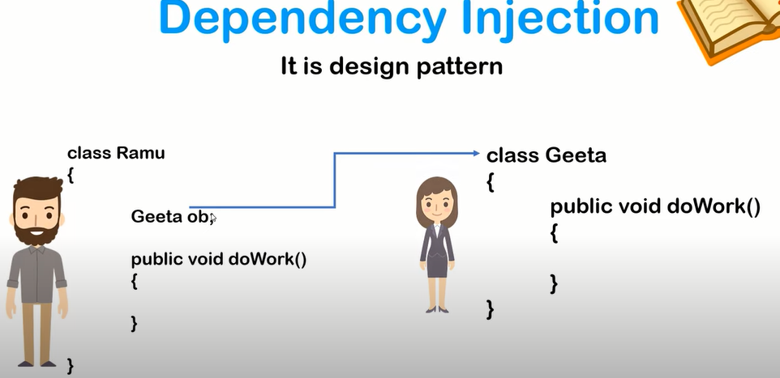

Note: Ramu is depending on Geeta.

Inversion of control(IOC):

=====================

Object creation control gives to spring instead of manually developers creation. Spring will create object in run time and will do inject that is inversion of control.

Without IOC:

===========

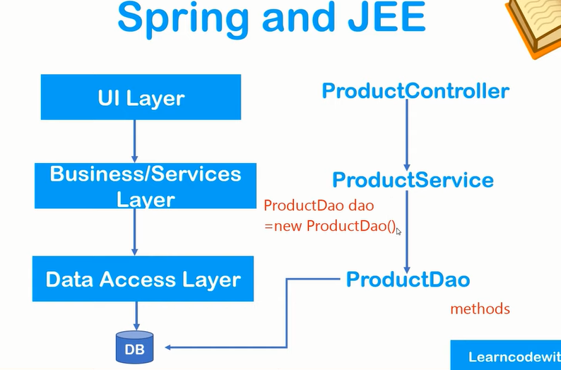

With IOC(benefit of spring):

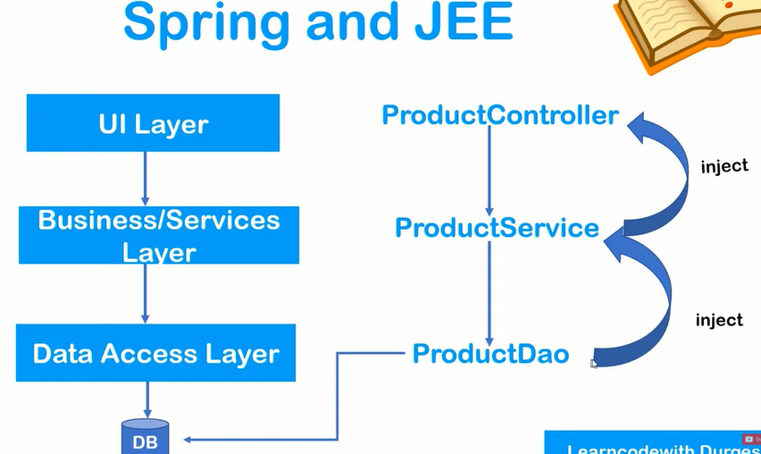

Final overview:

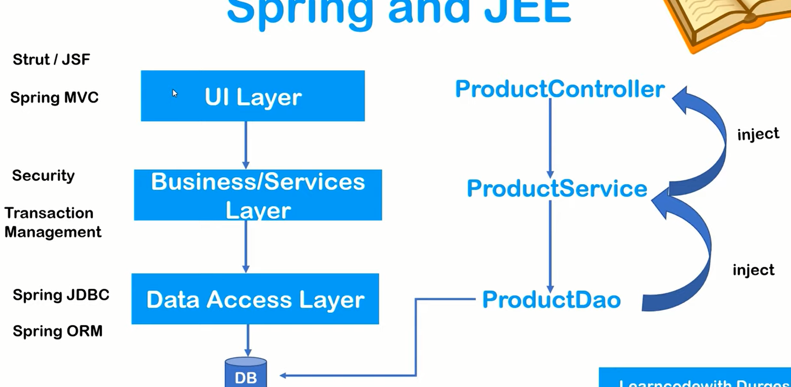

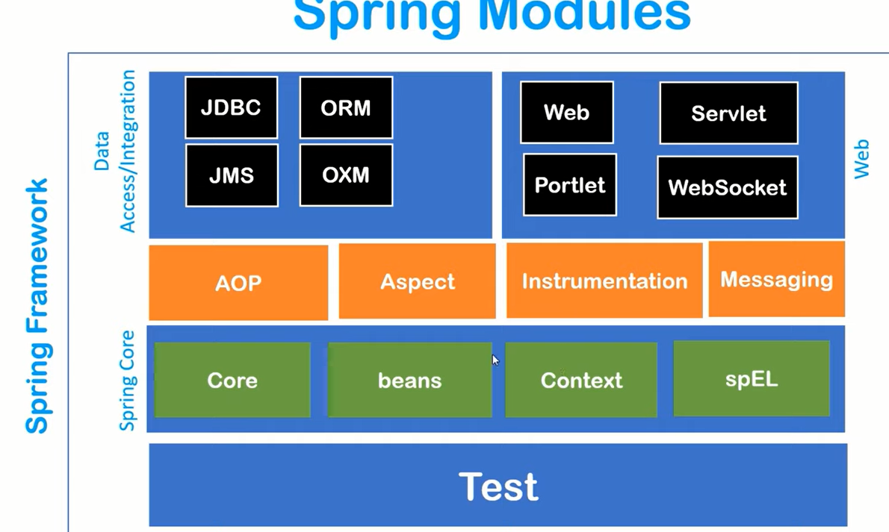

Spring IOC container:

===========================

In spring project, spring IOC container combine automatically.

3 top task IOC do:

1. Create object.
2. Hold them in memory
3. Inject them in another object as required.

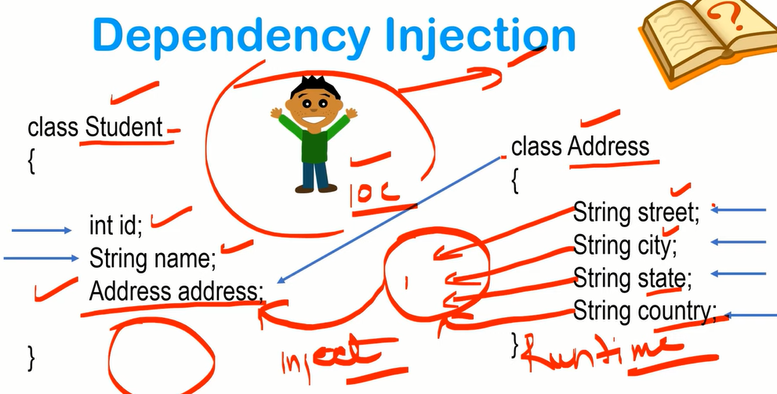

Dependency Injection can be done in two ways.

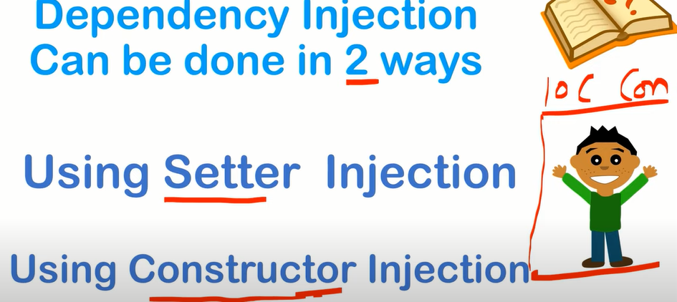

Setter Injection:

=============

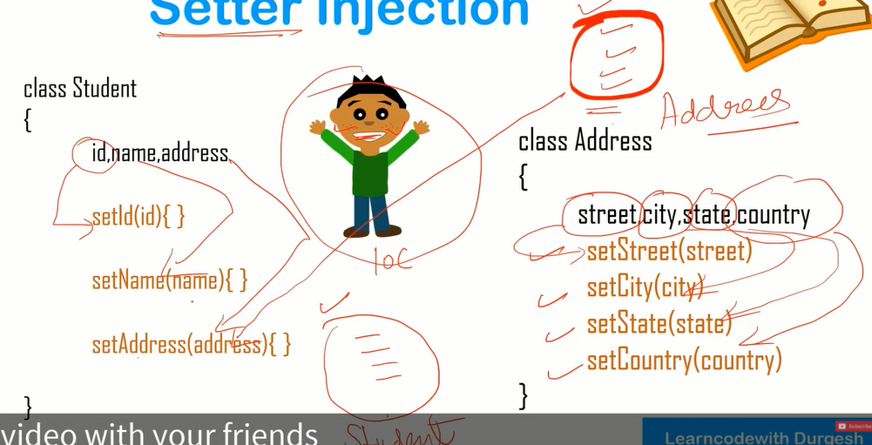

Constructor injection:

==================

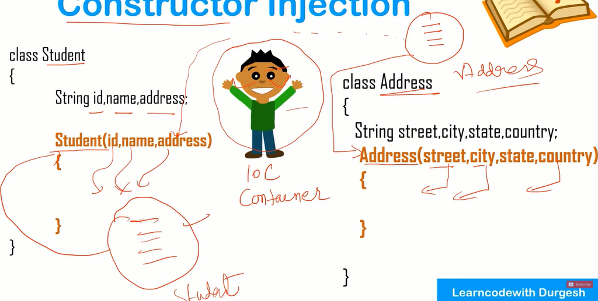

Configuration file:

===============

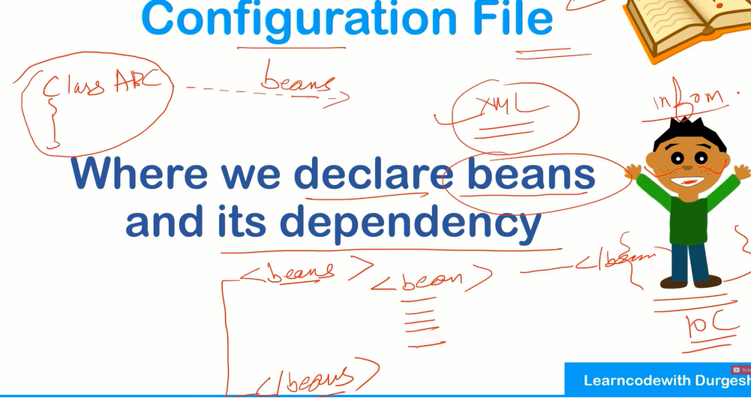

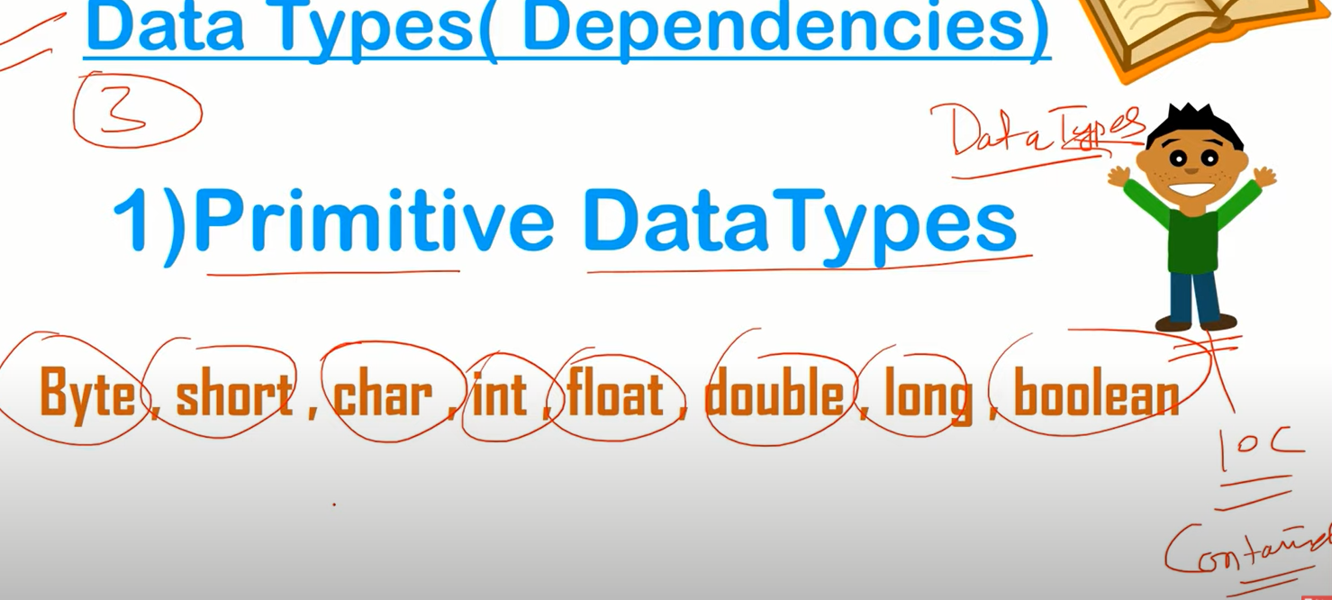

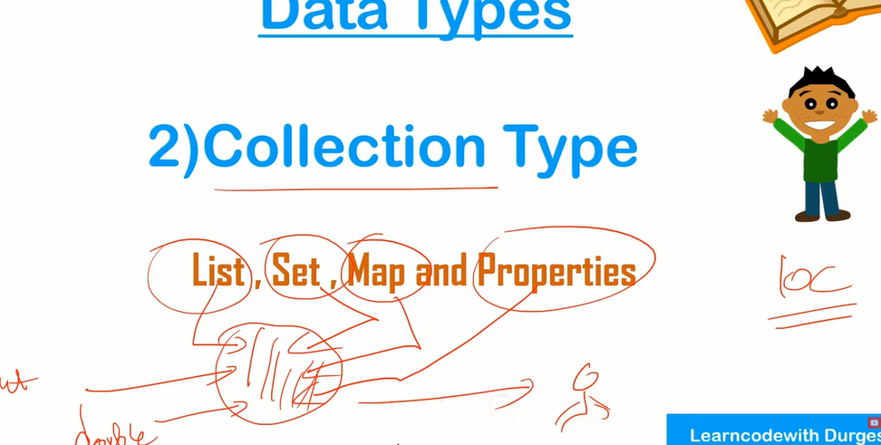

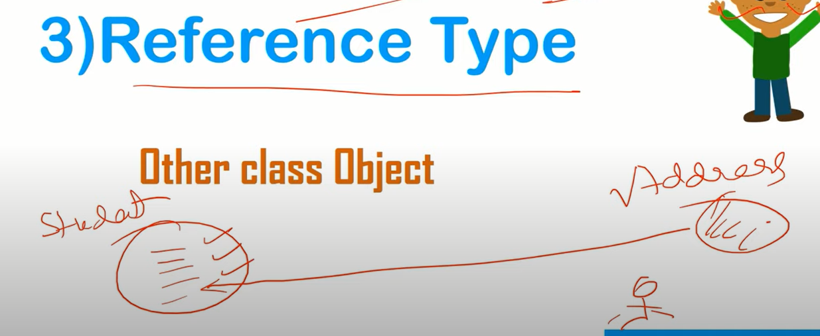

Note: Beans basically an object or class.